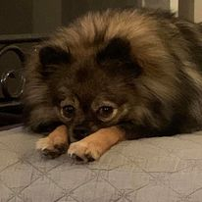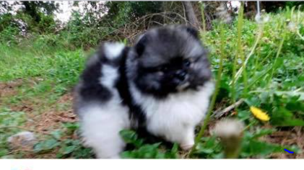

Chantilly Lace Pomeranians

10790 Pioneer Mill Road

Concord, NC 28025

734-368-0036

I, Leah Kunzelman hereby sell the following puppy/dog described as follows:

|  |  |
| --- | --- |
| Date of Birth |  |
| Sire |  |
| Dam |  |
| Sex |  |
| Color Markings |  |

This puppy is AKC registered and will come with full/partial AKC papers. However, this puppy/dog is being sold with no warranties either expressed or implied, in as is condition with no guarantees including size and color other than those states herein:

To the best of my knowledge this puppy/dog is free of disease and genetic defects at the date of this sale. The buyer has 72 hours from the time they pick up the puppy/dog to have a puppy/dog checked by a veterinarian of their choice at the buyer’s expense. If the buyer’s vet exam reveals that the puppy/dog is diseased or a genetic defect is found and a veterinarian of breeder’s choice concurs with the diagnosis, the buyer may return the puppy/dog to the breeder at the buyer’s expense. The breeder will also give a one-year guarantee against life threatening genetic defects such as heart lung and liver. If shipping is required puppy must be shipped by air or carrier from Concord, NC. Notice of intent to return must be given to the breeder within 72 hours of the date of this sale along with a statement in writing from the buyer’s veterinarian as to the health problem. A replacement puppy/dog will be made when one becomes available, and a replacement puppy is the only option. There is no guarantee against accidents. There is no guarantee against sickness not contracted on the breeder’s premises. No veterinary bills will be paid by the breeder. The puppy/dog has had temporary inoculations against distemper and Parvo virus following Dr. Jean Dodds vaccination protocol. The puppy/dog has been wormed but may need to be wormed again at the discretion of your veterinarian. Luxated patella, hernia, kennel cough, coccidian, giardia, and worms are not serious health problems if treated and therefore not covered in this warranty. Hypoglycemia IS a serious health problem but is not covered by this warranty as this is generally caused by too much activity and/or too little food and is within your control. Please contact the breeder and veterinarian if pup is not eating properly or if puppy has runny stools for more than 12 hours. If pup is lethargic contact veterinarian and breeder immediately!! Please be sure to feed your new baby at least every 3 hours It is agreed that at no time will the new owner sell or give this animal to a pet store, puppy mill, dog pound or broker or similar enterprise. The breeder will be notified in the event the new owner needs to find a new home for the puppy/dog for the possible placement assistance. Buyer agrees that this puppy/dog will become a member of the family to assure proper development and maintenance of the temperament for which this puppy was bred. The buyer agrees that this puppy/dog is NOT to be left in a backyard kennel. Buyer agrees seller will repossess puppy/dog upon evidence of neglect and/or abuse at no expense to the seller. Buyer will be held responsible for all legal and travel fees deemed necessary to repossess the puppy/dog. Buyer agrees that he/she understands this contract fully, and that this contract is under the jurisdiction of the state of North Carolina, in the count of Carrubus. It is agreed that the place of venue shall be Concord, NC and that deposits are non-refundable, no exceptions. By signing this contract I have read and understood the information in this contract and agree to all terms.

|  |  |
| --- | --- |
| Breeder: |  |
| Breeder Signature |  |
| Date: |  |
| New Owner: |  |
| Address: |  |
| Email: |  |
| Cell phone: |  |
| Signature: |  |
| Date: |  |